**Software Requirements Specification**

**for**

Empower Maine

**Version 1.0 approved**

**Prepared by Team A**

**10/06/24**

**Table of Contents**

**Table of Contents ii**

**Revision History ii**

**1. Introduction 1**

1.1 Purpose 1

1.2 Document Conventions 1

1.3 Intended Audience and Reading Suggestions 1

1.4 Product Scope 1

1.5 References 1

**2. Overall Description 2**

2.1 Product Perspective 2

2.2 Product Functions 2

2.3 User Classes and Characteristics 2

2.4 Operating Environment 2

2.5 Design and Implementation Constraints 2

2.6 User Documentation 2

2.7 Assumptions and Dependencies 3

**3. External Interface Requirements 3**

3.1 User Interfaces 3

3.2 Hardware Interfaces 3

3.3 Software Interfaces 3

3.4 Communications Interfaces 3

**4. System Features 4**

4.1 System Feature 1 4

4.2 System Feature 2 (and so on) 4

**5. Other Nonfunctional Requirements 4**

5.1 Performance Requirements 4

5.2 Safety Requirements 5

5.3 Security Requirements 5

5.4 Software Quality Attributes 5

5.5 Business Rules 5

**6. Other Requirements 5**

**Appendix A: Glossary 5**

**Appendix B: Analysis Models 5**

**Appendix C: To Be Determined List 6**

**Revision History**

| **Name** | **Date** | **Reason For Changes** | **Version** |
| --- | --- | --- | --- |
|  |  |  |  |
|  |  |  |  |

# **Introduction**

## **Purpose**

EmpowerMaine is an application designed to educate and support individuals with financial challenges or neurodiversity, on how to succeed in the tech industry. Its primary goal is to provide users with valuable resources, guidance, and connections to potential opportunities that can help them succeed professionally. The following document outlines the software requirements needed to develop this application.

## **Document Conventions**

This Document was created based on the IEEE template for System Requirement

Specification Documents.

The following conventions in the document were used as follows:

| **Convention** | **Description** |
| --- | --- |
| EM | App Name: EmpowerMaine |
| Express | Node.js Backend API |

## **Intended Audience and Reading Suggestions**

This document will be made for developers, project managers, users, testers, marketing staff, and document writers.  The rest of this SRS contains Product Scope, An overall description of the product, External Interface Requirements, System Features, Nonfunctional Requirements, and Other Requirements.

## **Product Scope**

EM’s purpose is to act as a resource hub for individuals with financial challenges or neurodiversity for how to succeed in the tech industry. The software promotes long-term engagement by supporting users as they navigate their careers and personal development. By offering continuous education, support, and connection to opportunities, EmpowerMaine’s aims to foster loyal users who return to the platform throughout various stages of their professional journey.

## **References**

Git Hub Link: <https://github.com/COS420-Fall24/TeamA>

# **Overall Description**

## **Product Perspective**

EM is being developed for anyone in Maine who is pursuing a career in technology. The main focus is to connect students with possible employers while taking many factors into account such as low income and neurodivergent users. We aim to help with the whole process from interview prep, tone checking for emails and correspondence, interview prep, learning assistance, and helping you find employers that fit different needs for different users.

## **Product Functions**

* Input Username: Allows the user to put in a username to log in.
* Input Password: Allows the user to put in a password to log in.

Interview prep

* Providing resources for interview prep
* Personal interviews
* Technical interview s

Job searches

* Gives options to narrow job search field

Tone checking with AI assistance

* Using the help of generative AI will be able to check others communication for their tone.
* Using the help of generative AI will be able to check your communication to see how your tone would come across and assist in changing to fit your desired tone.

Learning resources

* Provides learning resources for different field you may need to work on for employers

## **User Classes and Characteristics**

*<Identify the various user classes that you anticipate will use this product. User classes may be differentiated based on frequency of use, subset of product functions used, technical expertise, security or privilege levels, educational level, or experience. Describe the pertinent characteristics of each user class. Certain requirements may pertain only to certain user classes. Distinguish the most important user classes for this product from those who are less important to satisfy.>*

## **Operating Environment**

*<Describe the environment in which the software will operate, including the hardware platform, operating system and versions, and any other software components or applications with which it must peacefully coexist.>*

## **Design and Implementation Constraints**

*<Describe any items or issues that will limit the options available to the developers. These might include: corporate or regulatory policies; hardware limitations (timing requirements, memory requirements); interfaces to other applications; specific technologies, tools, and databases to be used; parallel operations; language requirements; communications protocols; security considerations; design conventions or programming standards (for example, if the customer’s organization will be responsible for maintaining the delivered software).>*

## **User Documentation**

*<List the user documentation components (such as user manuals, on-line help, and tutorials) that will be delivered along with the software. Identify any known user documentation delivery formats or standards.>*

## **Assumptions and Dependencies**

*EmpowerMaine is developed in HTML, CSS, and Java Script.  We are assuming users are not blocking Java Script, if they are our application will not work on their device.*

# **External Interface Requirements**

## **User Interfaces**

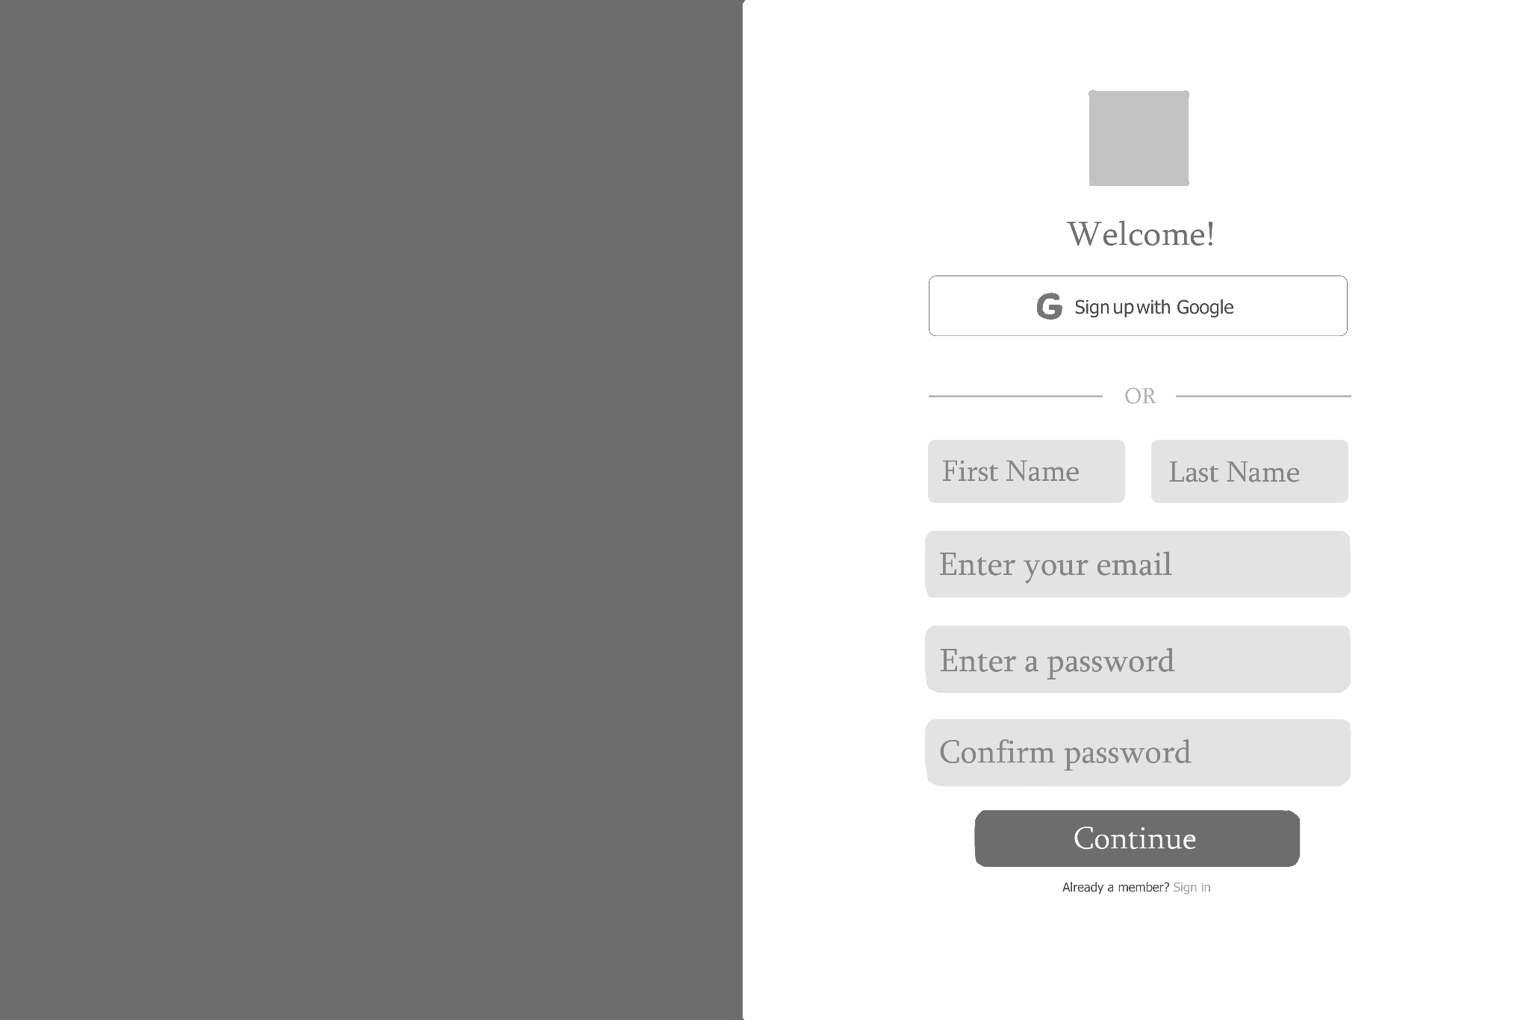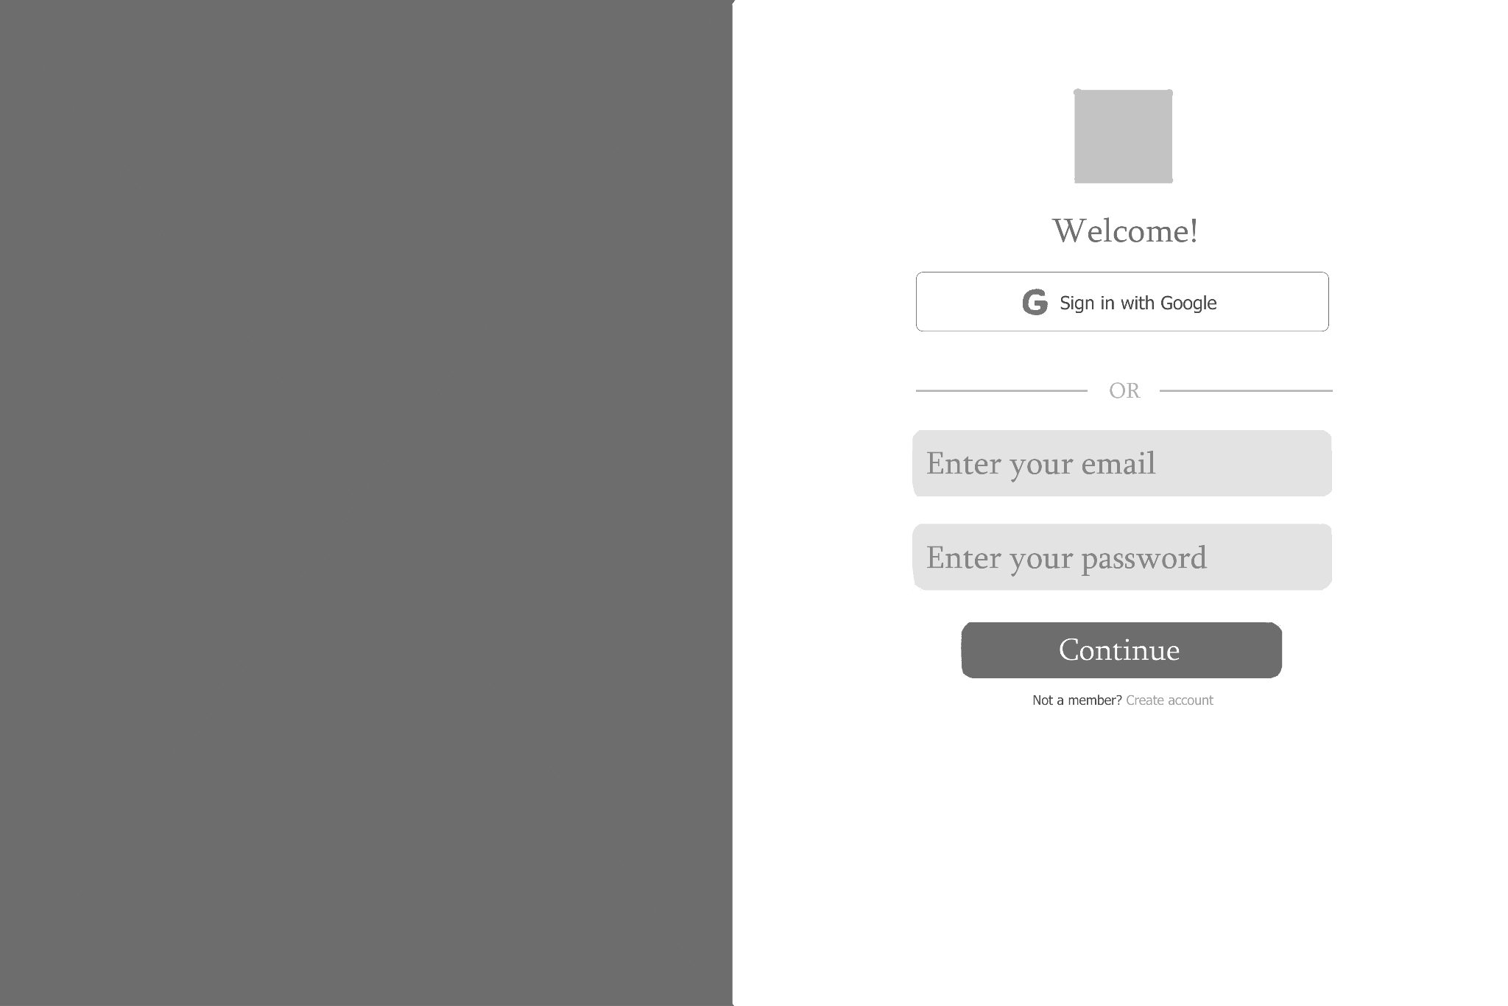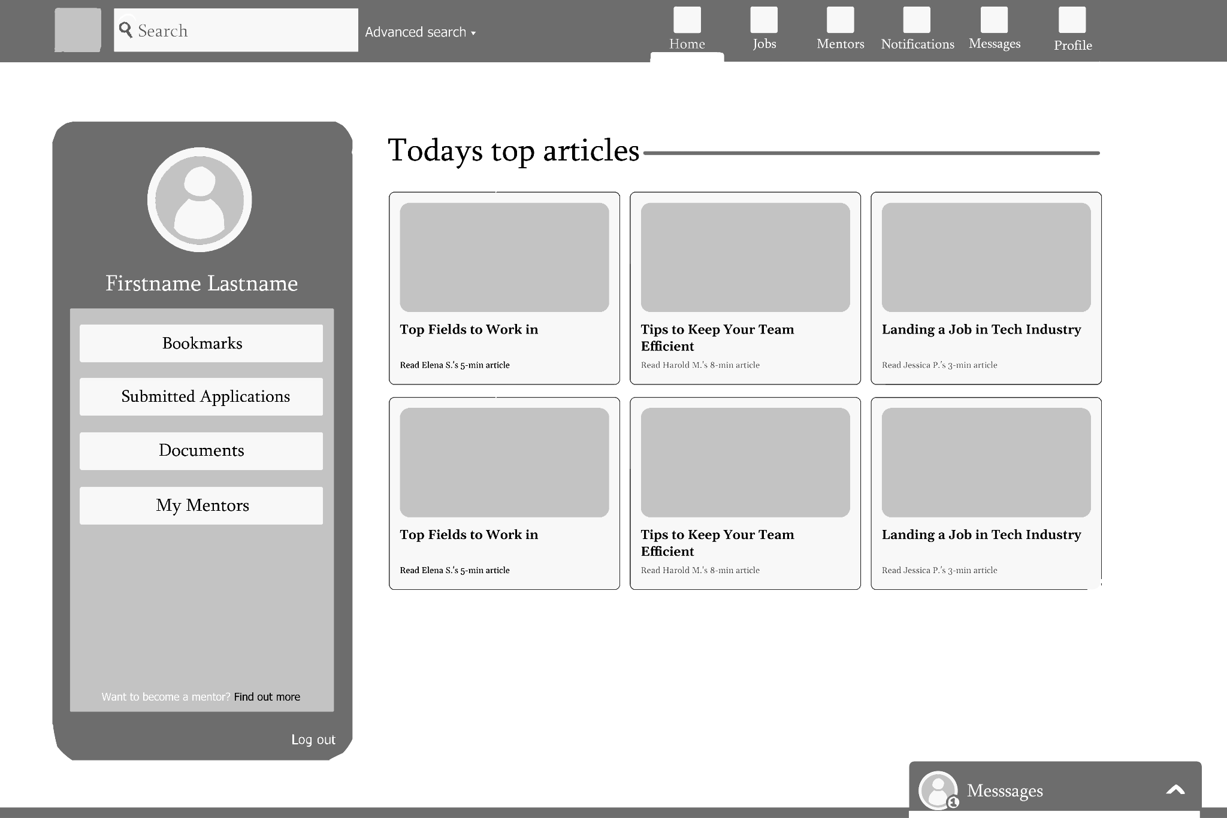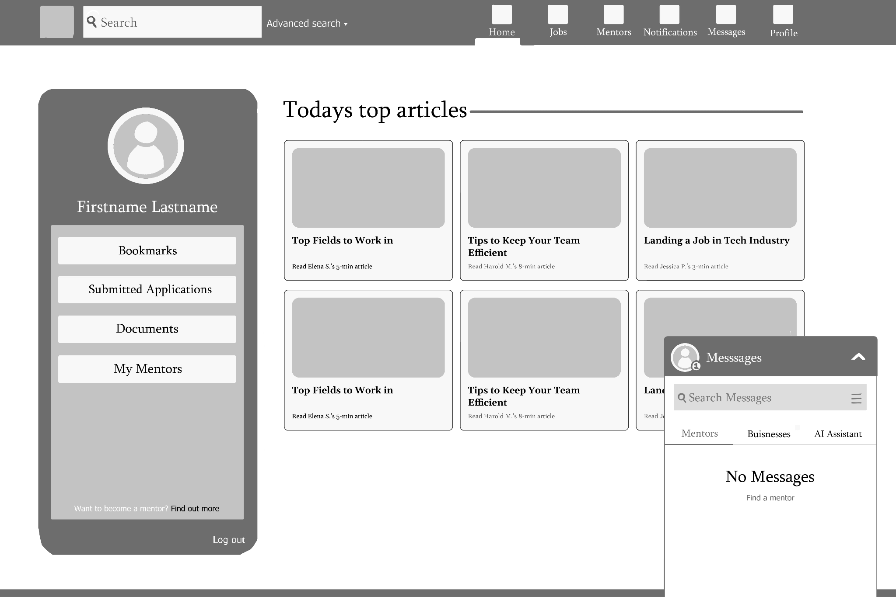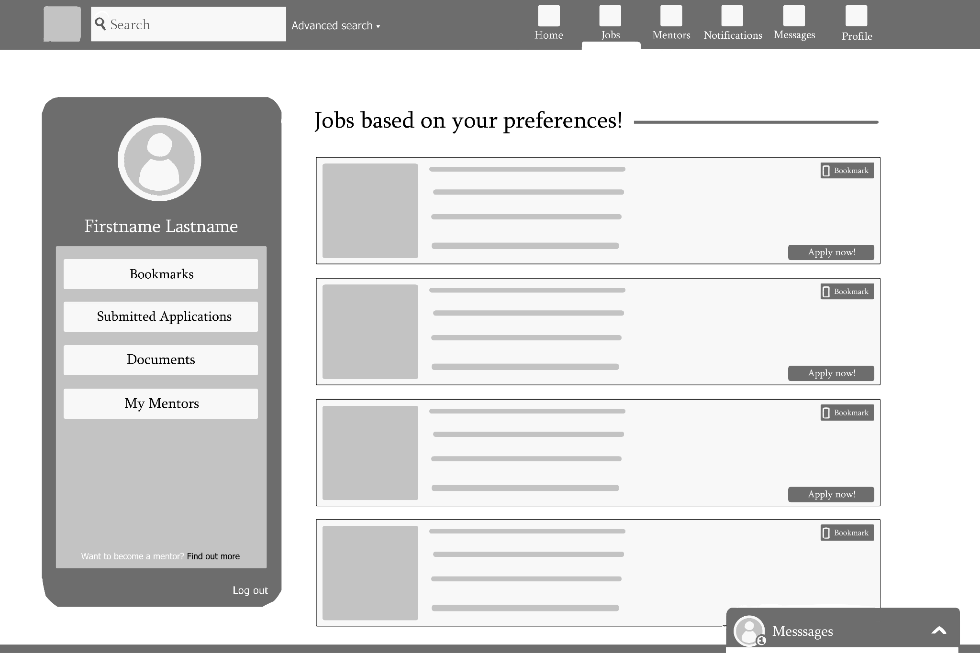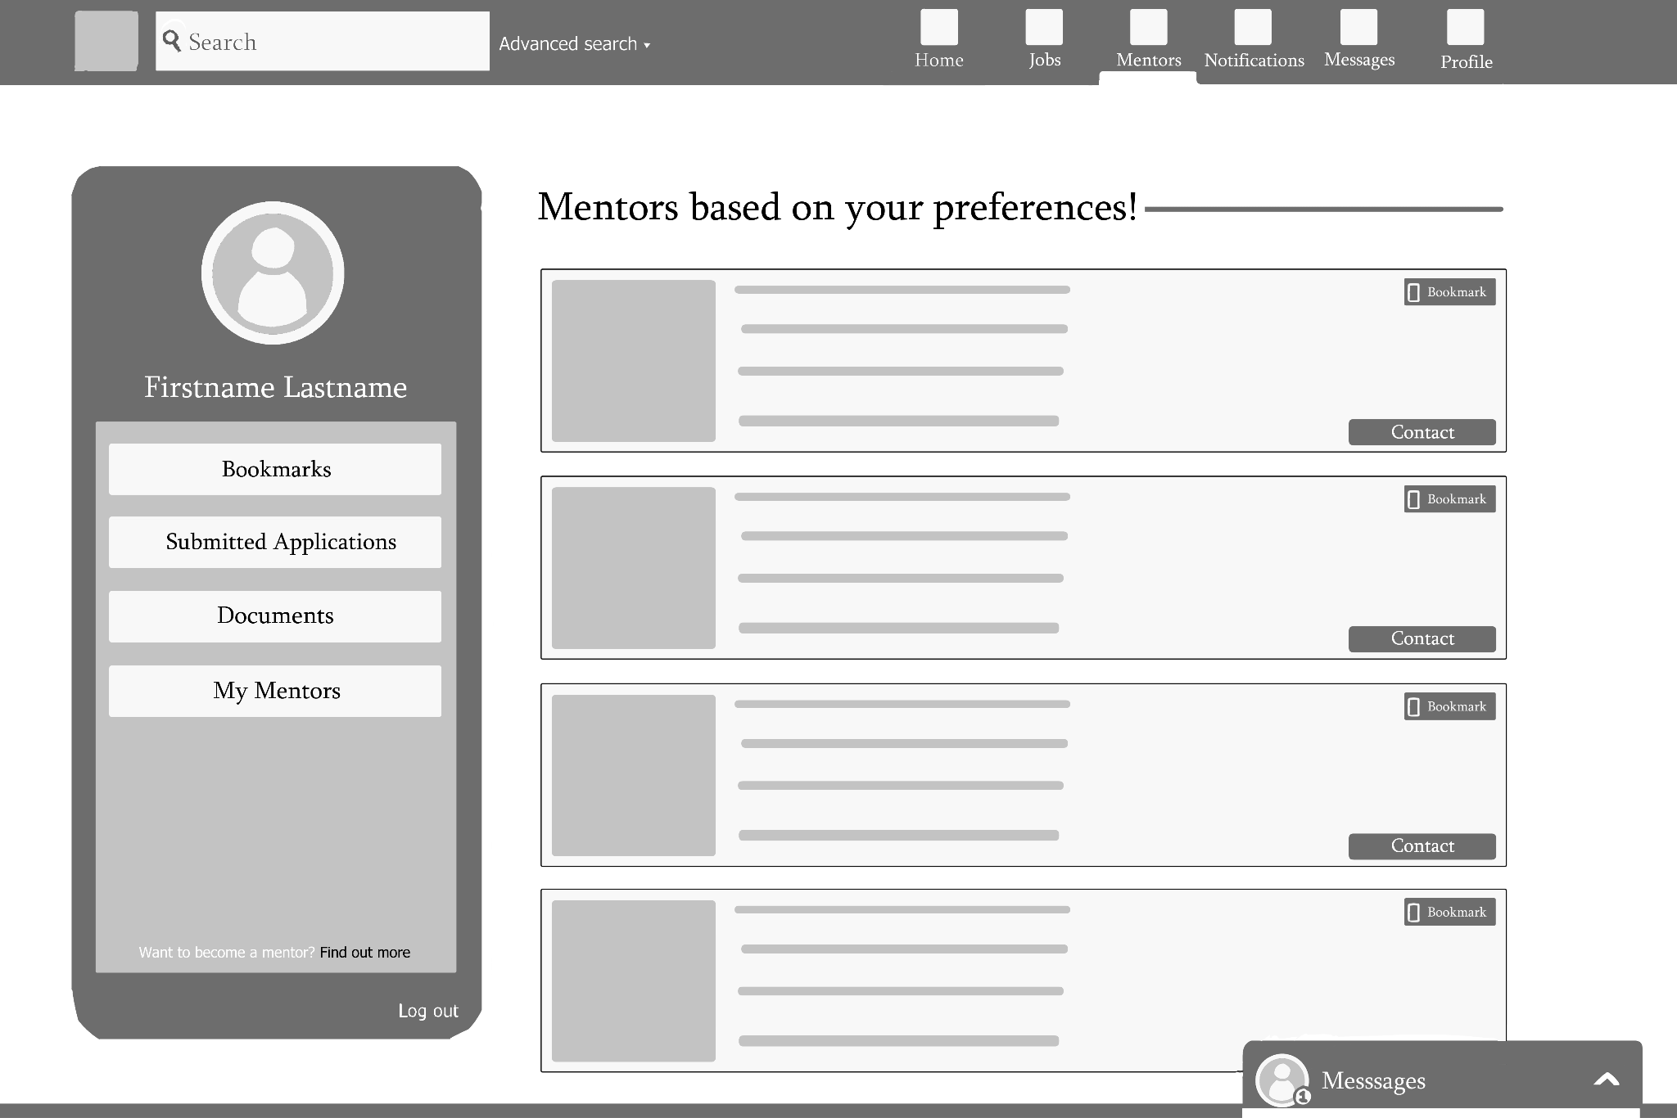

The first two images are for the sign up and sign in pages. Each of them have links to the other in case the user already has an account but is on the signup page or if the user doesn't have an account but is on the sign in page.

The next 4 images show the main screen for the website. On the left is a static profile area for easy access to things like bookmarked listings or uploaded documents. On the bottom right is a messaging window that can be extended to allow messaging while on other pages of the website. Along the top is a navigation bar with tabs for things like job listings or an extended full size messaging page. The home page has articles written by mentors.

The website is designed to be formatted so that the various pages always maintain the static profile window and message window.

## **Hardware Interfaces**

Supported devices will include a device capable of running a browser (such as Google Chrome, Firefox, and Safari) that can render JavaScript and a visual interface that is able to render computer graphics on a screen. These devices include a PC, laptop, or smart phones. The server must be listening on an open port and accessible through a public IP address, so that clients can send and receive data back and forth from it. The client must be able to establish and maintain a TCP session with the server, ensuring reliable communication throughout their interaction.

## **Software Interfaces**

The application will utilize the following technologies and versions:

* **Node.js**: v16
* **Express**: v4.21.1
* **React**: v18.2.0 (including react-dom and react-router-dom as dependencies)
* **Webpack**: v5.95.0 for bundling frontend code into a single-page application (SPA)
* **Firebase**: v10.14.1, with necessary configurations in the Firebase Console
* **Firebase Admin**: v12.6.0 for backend services

The server may use any operating system as long as it is capable of running Node.js, can install the needed dependencies, and listen on an open port.

A Firebase account will be required to act as a focal point for user registrations, email verifications, and other necessary database procedures.

Messages that may be sent to the system:

* Account registration details
* Account login details
* Search details for listings (jobs, mentors, etc.)
* User-submitted messages for a chat application
* Listings posted by a recruiter
* Listings posted by a mentor
* User requests for a mentor
* User submissions to job applications

Messages the system may send out:

* index.html file importing a bundle.js which defines all client logic
* Confirmation responses to requests in the form of JSON data
* Email sent to user for email verifications and account confirmation
* Email sent to user including TOS of website

## **Communications Interfaces**

The Express web server will listen for requests on the HTTP/HTTPS protocol, automatically redirecting HTTP traffic to HTTPS to ensure secure communications. Google’s Firebase platform will be utilized for storing and maintaining site database information, as well as handling core features such as user registration and account activation.

# **System Features**

**4.1 Account creation**

4.1.1 Description and priority

This feature allows a user to create an account with their name, email, and a password. This is a medium priority feature

4.1.2 Stimulus/Response Sequences

-The user types their first name into the first name bar

-The user types their last name into the last name bar

-The user types a email into the email bar

-The user types a password into the password bar and the confirm password bar

-The user clicks Continue button to make account

-The user is sent to their profile management page

-If the user already had an account they can click the sign in button instead to be sent to the sign in page

4.1.3 Functional requirements

REQ-1: The system shall allow users to create an account with a username and password.

**4.2 Profile management**

*4.2.1 Description and priority*

This feature allows a user to add and edit information on their profile page. This includes information such as their financial situation, their needs due to any neurodiversity, their credentials, and their location information. High priority

*4.2.2 Stimulus/Response Sequences*

- The user clicks on their profile-pic on the left side of the homepage or the user clicks on the profile tab on the navigation bar at the top of the screen

- The user is sent to the profile management page

- By navigating tabs along the left side such as Credentials, Or Neurodiversity

the user can move through the different sections of their profile

- In each section is a checkbox labeled, Not applicable. If this is checked the section will be grayed out and the users profile will update to add an N/A to that section

- If the Not applicable checkbox is not checked the user can click on any of the sections and fill in their information accordingly

- In the top right is a button labeled preview profile, If clicked the user will be shown a preview of how their profile will look to other users or businesses that view it.

- The changes are not saved until the button, Save changes, is clicked

- Besides the save changes button is a cancel changes button. If this is clicked the profile will reset its information back to its last saved state

*4.2.3 Functional requirements*

REQ-3: The system shall allow users to either remain anonymous or enter their location and personal information to find nearby learning or internship opportunities.

REQ-6: The system shall allow users to create a profile.

REQ-12: The system shall allow users to specify their neurodiversity or financial status (optional) to receive tailored job, mentor, and resource suggestions.

REQ-13: The system shall allow users to specify completed credentials in their profile

REQ-15: The system shall allow users to specify needs from employers based on issues caused by being neurodivergent or low income in user profile. (ex, needing public transportation, needing flexible work hours, etc)

**4.3 Search functionality**

4.3.1 Description and priority

This feature allows the user to search for listings and resources using the search bar at the top right of the window. It has an advanced search option where keywords and specifications can be used to get more accurate results. The mentor page and the job page automatically suggest listings based on provided profile information. Priority high

4.3.2 Stimulus/Response

- The user clicks on the search bar and types in their search

- If the user clicks on advanced search a window will extend showing a series of keywords and other options such as part time/full time, Mentors only, or jobs only to allow a more specific search, By default the Use Profile Info box will be checked resulting in searches automatically providing results based on provided user information.

- If the user unchecks the use profile info option searches will simply search based on what was typed along with any other tags that were selected

-When the user hits enter they will be given a list of results based on their search

4.3.3 Functional requirements

REQ-5: The system shall allow users to search for topics and resources using tags and keywords.

REQ-2: The system shall allow users to find volunteer online mentors whose availability lines up with their own.

REQ-7: The system shall allow users to search for available mentors in the tech industry who specialize in helping neurodiverse or low-income individuals.

REQ-8: The system shall allow users to find jobs in the tech industry that are compatible with their current computer hardware and software limitations.

REQ-10: The system shall allow users to filter job and learning opportunities based on public transportation availability, schedule flexibility, and cost (free/low-cost opportunities).

REQ-14: The system shall allow users to filter jobs in the tech industry using job title, salary, location, and sector of tech

**4.4 Messaging functions**

4.4.1 Description and priority

This feature allows a user to message mentors, businesses, or an AI assistant. medium priority

4.4.2 Stimulus/Response Sequences

-The user can access the full messages page by clicking on the messages tab on the navigation bar at the top of the screen.

-The user can also click on the smaller messages tab at the bottom left

(In either case the stimulus and response is the same, the full page is just larger scale while the smaller is to allow messaging while browsing other parts of the site)

- The user clicks the mentor tab to see a list of all their current mentors names and a preview of the last message sent in each conversation

-If there is no mentors the user can click Find a mentor to be sent to the mentor tab

-The user clicks the business tab to see a list all their current messaged businesses names and a preview of the last message sent in each conversation

-The user clicks the AI assistant tab to see a messaging window formatted the same as the others, However, here they are messaging an AI assistant

-To send a message in any of the 3 sections the user clicks on the type message bar, types their message, and clicks the send button.

-On the left besides the type message bar is a button for uploading files that when clicked open the users file explorer to allow the uploading of files from their pc to the message

4.4.3 Functional requirements

REQ-4: The system shall allow users to communicate with other users and mentors with messaging functions within the app

REQ-9: The system shall allow users to use the Generative AI to improve the tone and clarity of their writing when applying for jobs or communicating with mentors.

**4.5 Bookmarking**

4.5.1 Description and priority

This feature allows a user to save mentors and job applications to their profile's bookmark page. Low priority

4.5.2 Stimulus/Response Sequences

-In either the jobs page or the mentor page the listed results each have a bookmark button on their upper right. If clicked the button will change to say bookmarked and the listing will be added to the users bookmarked listings.

-The user can reach their bookmark section by either clicking on bookmarks in the profile window on the right side of the screen or by going to the profile tab at the top and then clicking on the left hand bookmark tab.

-In the profiles bookmark section there are two lists of bookmarked listings, one for jobs and one for mentors

4.5.3

REQ-11: The system shall allow users to bookmark job or mentor listings for later access

# **Other Nonfunctional Requirements**

## **Performance Requirements**

*<If there are performance requirements for the product under various circumstances, state them here and explain their rationale, to help the developers understand the intent and make suitable design choices. Specify the timing relationships for real time systems. Make such requirements as specific as possible. You may need to state performance requirements for individual functional requirements or features.>*

1. The software shall remain accessible to users 99% of the time when not under scheduled maintenance
2. The software shall pull up any messages within 1 second of being requested

## **Safety Requirements**

*<Specify those requirements that are concerned with possible loss, damage, or harm that could result from the use of the product. Define any safeguards or actions that must be taken, as well as actions that must be prevented. Refer to any external policies or regulations that state safety issues that affect the product’s design or use. Define any safety certifications that must be satisfied.>*

## **Security Requirements**

*<Specify any requirements regarding security or privacy issues surrounding use of the product or protection of the data used or created by the product. Define any user identity authentication requirements. Refer to any external policies or regulations containing security issues that affect the product. Define any security or privacy certifications that must be satisfied.>*

1. The system shall use encryption for user data.
2. The system shall give the option for the user to share their general location while keeping their specific location hidden.
3. The software shall ask for permission to retrieve and display users location

## **Software Quality Attributes**

*<Specify any additional quality characteristics for the product that will be important to either the customers or the developers. Some to consider are: adaptability, availability, correctness, flexibility, interoperability, maintainability, portability, reliability, reusability, robustness, testability, and usability. Write these to be specific, quantitative, and verifiable when possible. At the least, clarify the relative preferences for various attributes, such as ease of use over ease of learning.>*

1. The software shall be compatible with modern IOS and Android devices
2. The software shall be able to automatically locate the users general location
3. The software shall load within 2 seconds of being launched.
4. The software shall display error message and return to home screen when an error is encountered

## **Business Rules**

*<List any operating principles about the product, such as which individuals or roles can perform which functions under specific circumstances. These are not functional requirements in themselves, but they may imply certain functional requirements to enforce the rules.>*

# **Other Requirements**

*<Define any other requirements not covered elsewhere in the SRS. This might include database requirements, internationalization requirements, legal requirements, reuse objectives for the project, and so on. Add any new sections that are pertinent to the project.>*

**Appendix A: Glossary**

*<Define all the terms necessary to properly interpret the SRS, including acronyms and abbreviations. You may wish to build a separate glossary that spans multiple projects or the entire organization, and just include terms specific to a single project in each SRS.>*

**Appendix B: Analysis Models**

*<Optionally, include any pertinent analysis models, such as data flow diagrams, class diagrams, state-transition diagrams, or entity-relationship diagrams*.>

**Appendix C: To Be Determined List**

*<Collect a numbered list of the TBD (to be determined) references that remain in the SRS so they can be tracked to closure.>*